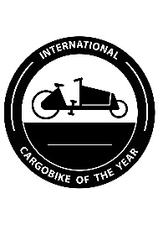

INTERNATIONAL CARGOBIKE OF THE YEAR 2020
Manufacturer/Typ:
Lenght x width x height (incl. Box):
Empty weight (without driver):
Payload (incl. driver 75 kg):
Gross vehicle weight:
Engine (Type/manufacturer/power):
Powertrain (Type/Position):
Gear Shift (Type/number of gears):
Brakes (Manufacturer/type):
Frame (Manufacturer/Material):
Design (long john/long tail/trike):
Lights (manufacturer/type):
Rims/Tires (format/manufacturer)
Price (base):
Standard equipment:
Extra equipment:

Description/remarks by manufacturer:

